

**THE UNIVERSITY OF TEXAS AT ARLINGTON, TEXAS  
DEPARTMENT OF ELECTRICAL ENGINEERING**

**EE 5356**

**DIGITAL IMAGE PROCESSING**

**PROJECT # 8**

**by**

**SOUTRIK MAITI**

**1001569883**

**Presented to**

**Dr. K.R.RAO**

**Mar 22, 2019**

**Histogram Equalization and Specification**

***MATLAB Code for the first image:***

%% Reading and displaying the first image

img = imread('elaine.512.tiff');

figure;

subplot(1,2,1);

imshow(uint8(img));

title('Original Image');

subplot(1,2,2);

%% Applying histogram equalization and displaying original image and it's histogram

imhist(img);

title('Oiginal Image Histogram');

saveas(gca,'origin_hist.jpg');

%% Performing Global Histogram Equalization

g_hist_img = histeq(img);

figure;

subplot(1,2,1)

imshow(uint8(g_hist_img));

title('Globally Equalized Histogram Image')

subplot(1,2,2)

imhist(g_hist_img);

title('Globally Equalized Histogram');

saveas(gca,'g_hist.jpg');

%% Performing Local Histogram Equalization

l_hist_img = adapthisteq(img,'clipLimit',0.01,'Distribution','rayleigh');

figure;

subplot(1,2,1)

imshow(uint8(l_hist_img));

title('Locally Equalized Histogram Image');

subplot(1,2,2)

imhist(l_hist_img);

title('Locally Equalized Histogram');

saveas(gca,'l_hist.jpg');

%% Direct Histogram (Straight Line)

st_l = linspace(0,1,512);

d_hist_img = histeq(img,st_l);

figure;

subplot(1,2,1)

imshow(d_hist_img);

title('Direct Histogram Image');

subplot(1,2,2)

imhist(d_hist_img);

title('Direct Histogram (Straight Line)');

saveas(gca,'d_hist.jpg');

*Results:*

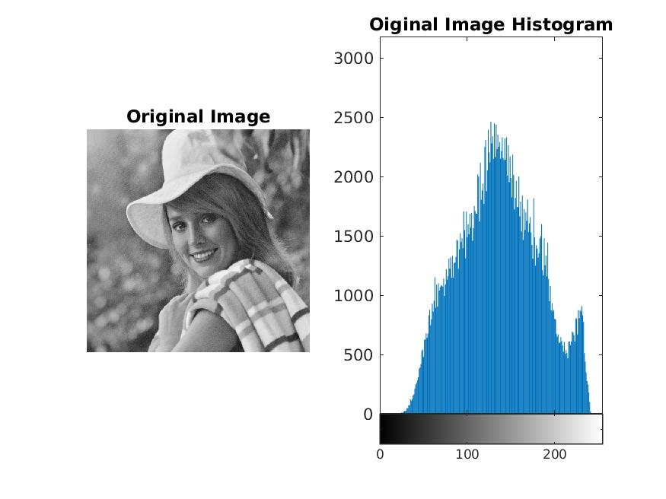

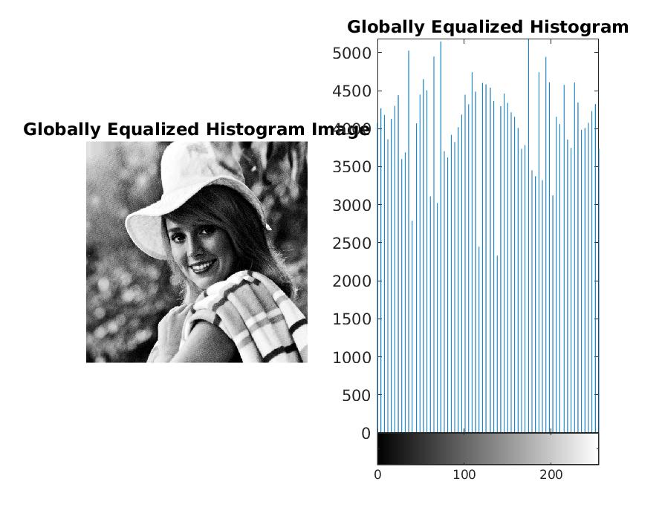

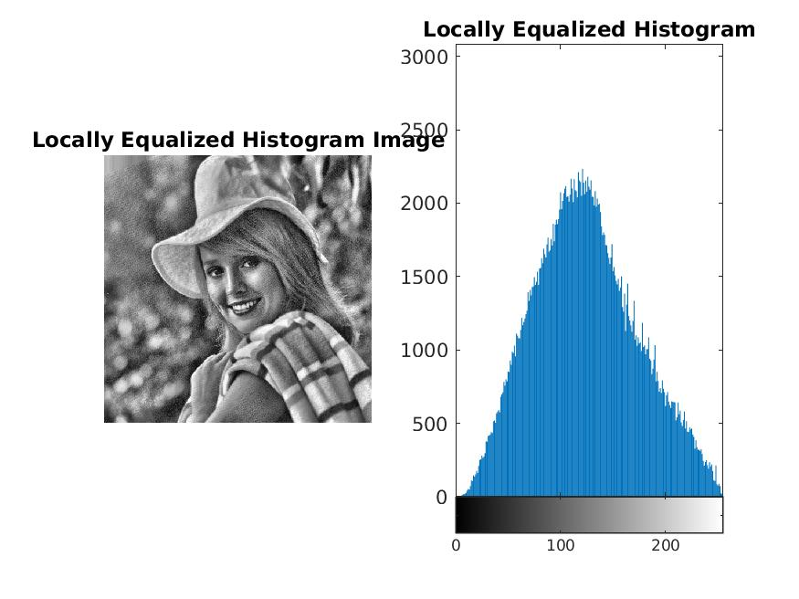

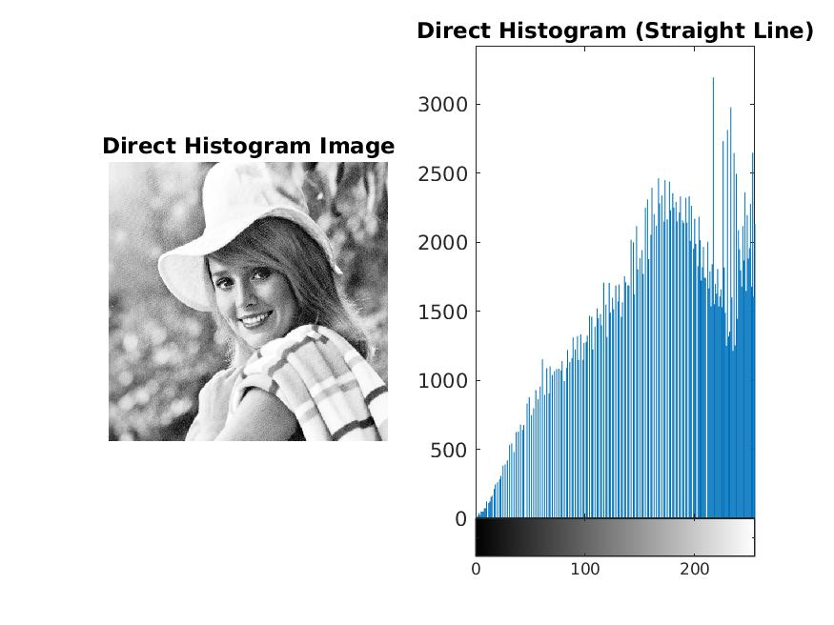

***MATLAB Code for the second image:***

%% Performing the same operations for the Second Image

img2 = imread('pout.tif');

figure;

subplot(1,2,1)

imshow(uint8(img2));

title('Orignal Image');

subplot(1,2,2)

imhist(img2);

title('Orignal Image Histogram');

saveas(gca,'origin_hist_2.jpg');

%% Global Hisogram Equalization

g_hist_img2 = histeq(img2);

figure;

subplot(1,2,1)

imshow(uint8(g_hist_img2));

title('Globally Equalized Histogram Image');

subplot(1,2,2)

imhist(g_hist_img2);

title('Globally Equalized Histogram');

saveas(gca,'g_hist_2.jpg');

%% Local Histogram Equalization

l_hist_img2 = adapthisteq(img2,'clipLimit',0.01,'Distribution','rayleigh');

figure;

subplot(1,2,1)

imshow(uint8(l_hist_img2));

title('Locally Equalized Histogram Image');

subplot(1,2,2)

imhist(l_hist_img2);

title('Locally Equalized Histogram');

saveas(gca,'l_hist_2.jpg');

%% Direct Histogram (Straight Line)

st_l = linspace(0,1,512);

d_hist_img2 = histeq(img2,st_l);

figure;

subplot(1,2,1)

imshow(d_hist_img2);

title('Direct Histogram Image');

subplot(1,2,2)

imhist(d_hist_img2);

title('Direct Histogram (Straight Line)');

saveas(gca,'d_hist_2.jpg');

***Results:***

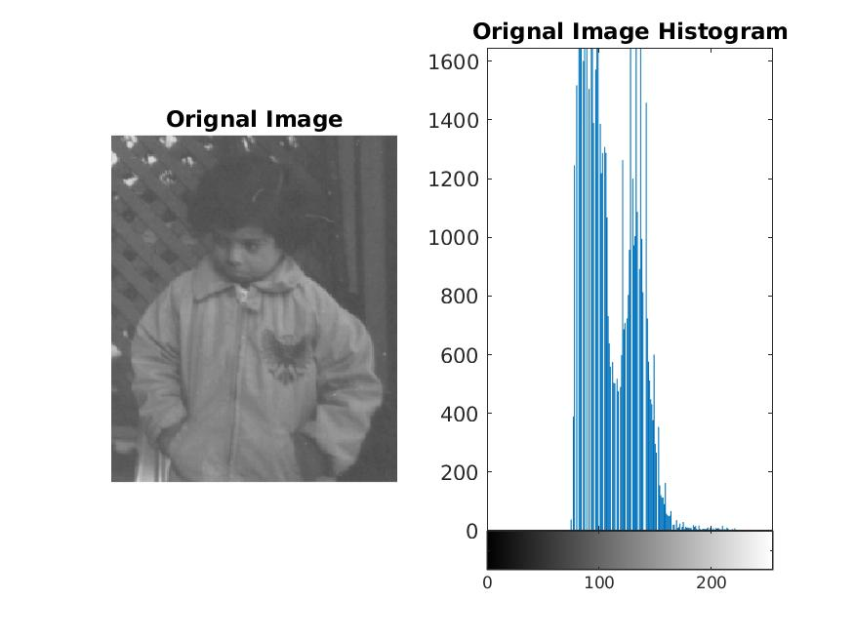

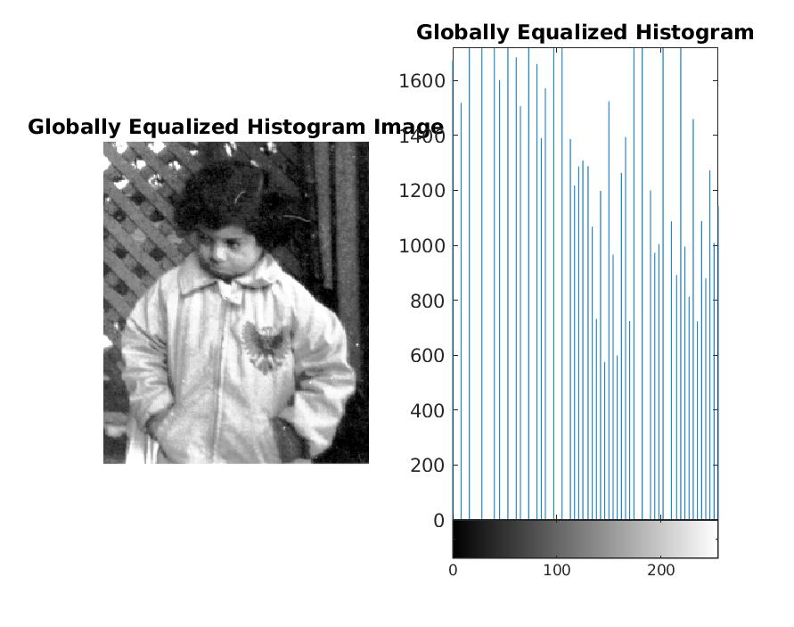

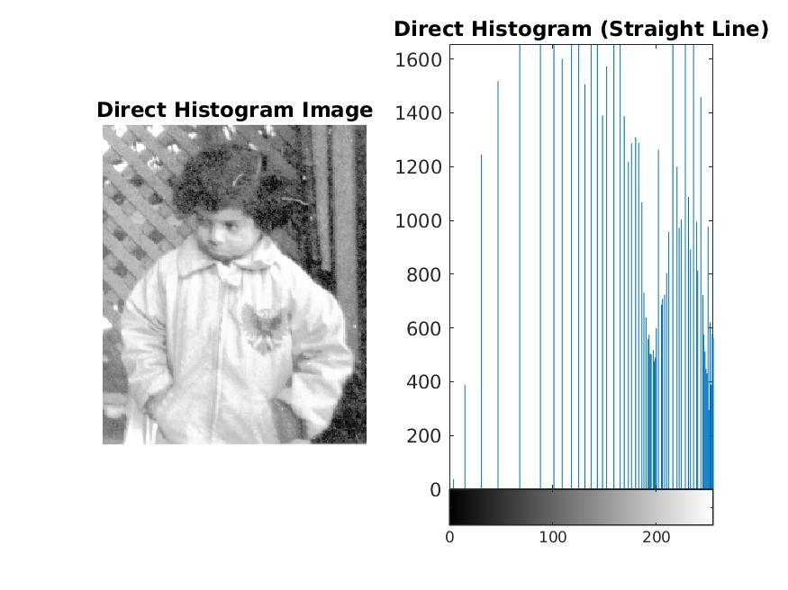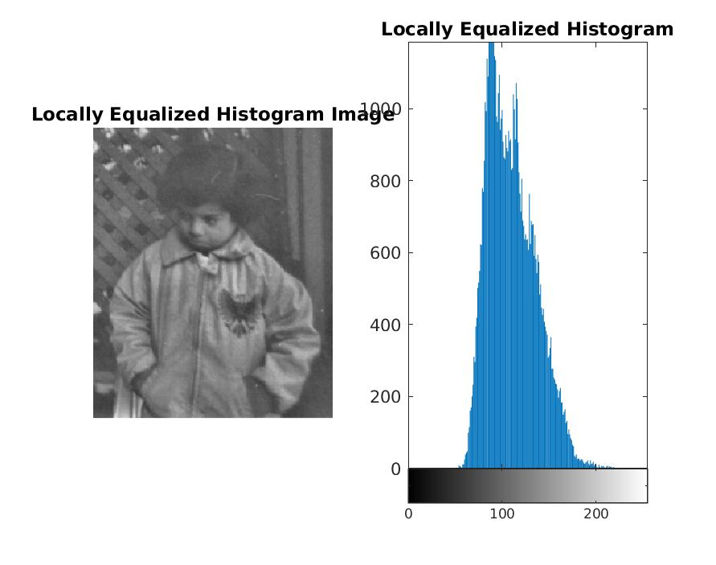

***Conclusion:***

* *Global histogram uses full range and brings up the contrast of the image by intensifying the pixels.*
* *The histogram is shaped according to the distribution (Rayleigh in our case, the Local histogram is distributed according to the Rayleigh curve)*
* *Pixel intensities are distributed according to a straight line in Direct Histogram Equalization.*
* *Histogram equalization is used to change the contrast of the image by spreading out the most frequent intensities.*